
SOP Title: | eCommerce STO Verification Process
Document Storage Location: | STACS/Management/SOPs – Logistics and Warehousing | Document #: | SEASOP386V100
SOP Originator: | Alie Armstead | Last Edited by: | Viraj Baraskar
Effective Date: | 07/31/2020 | Last Edited Date: | 08/01/2020
Other:

- Purpose
- To identify and document the process for the eCommerce(eComm) STO verification process.

- Scope
- Coppell eComm– How to create an STO Verification Report.

- Responsibilities
- SEA Operations team shall be responsible for providing support and resolution for system processing errors reported by 3PL Instructions

- Instructions
- These instructions explain how to create the STO Verification Report:
  - The tabs on the spreadsheet to be created are:
    - Transportation_load_plan: This sheet has the data for the STOs for all the different carriers.
    - eComm Data: This sheet has the data for eComm for the period entered
    - GI to Geodis: Includes every STO that has been Goods Issued to Geodis at the time of the report.
    - North Dock Pending STOs: Has the status of all open STO’s not Good Issued to Geodis at the time of the report.
    - Inbound Floor: Lists all STOs which should be on the inbound floor.
- Transportation_load_plan:
  - Using SAP log-in to your WMP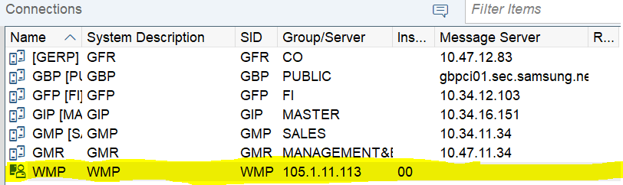

  - Enter T-Code ZSTA30090 in the command field
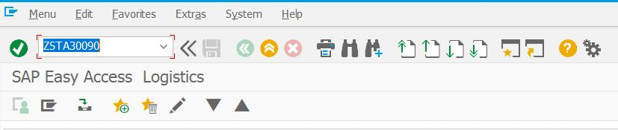
  - Follow the three steps shown below
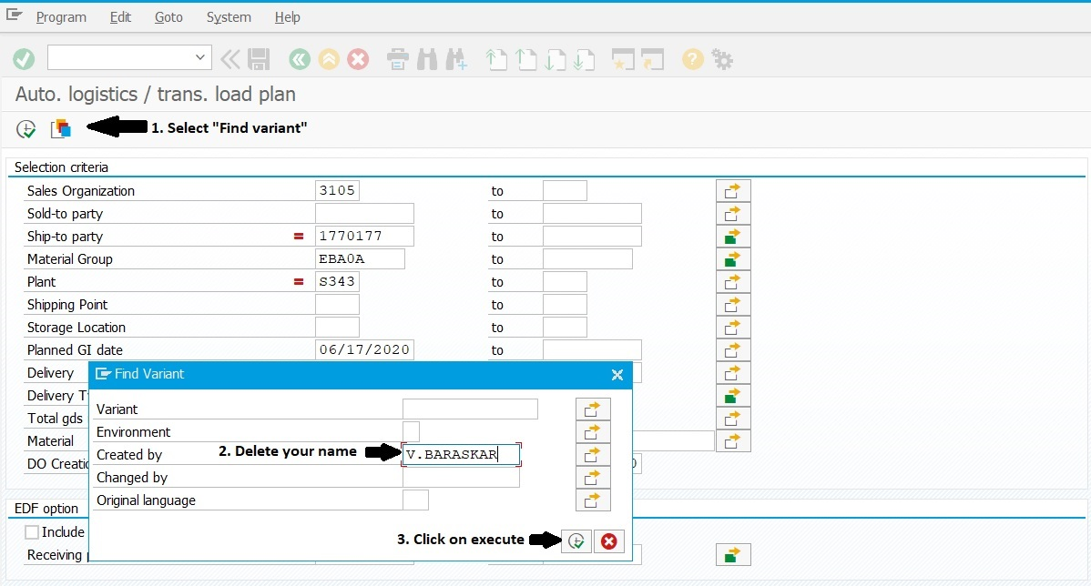
  - Scroll down and select the variant name, “WT-ACC-UB-WIMA”, then select “Execute”(checkmark).
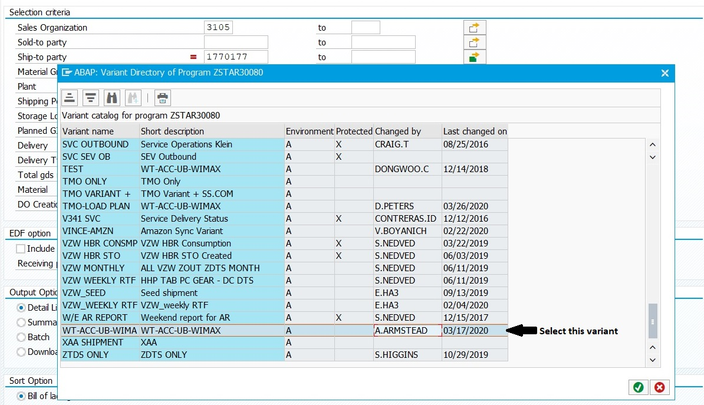

  - Generate the report by selecting the execute icon.
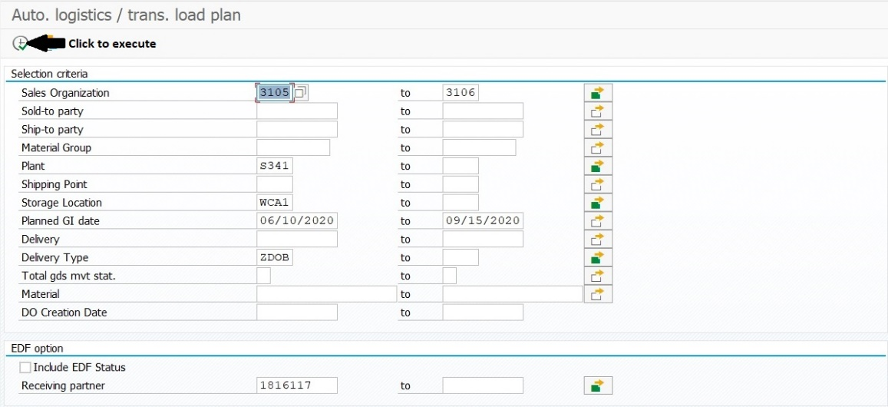
  - Follow the two steps shown below
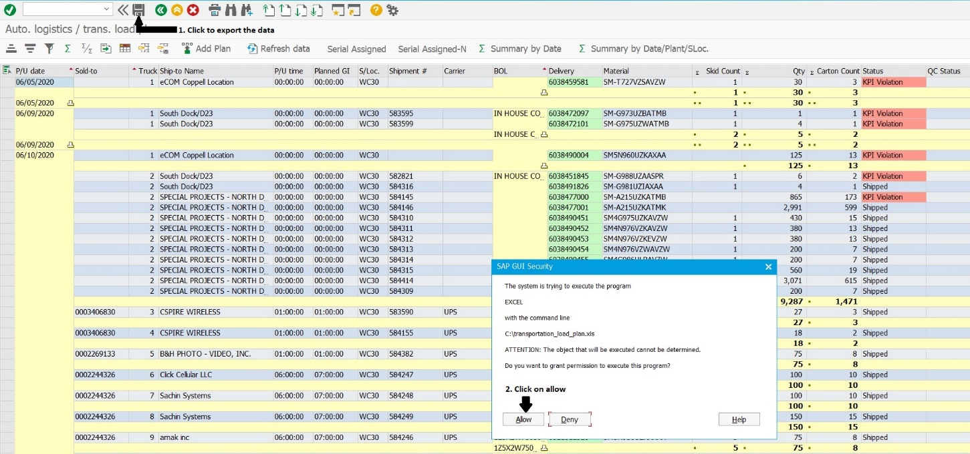
  - Accept the file format and extension.
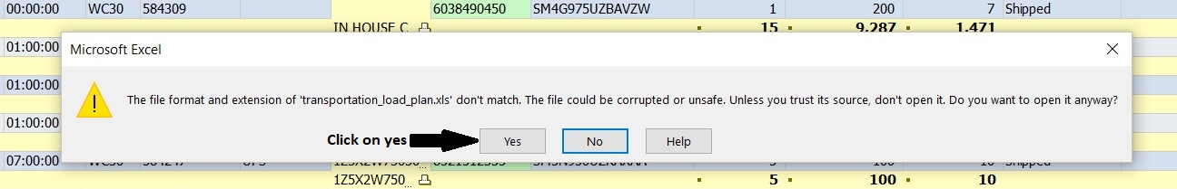

  - Save the spreadsheet as an .xlsx file to your desired location and rename the file (Pending North Dock STO).
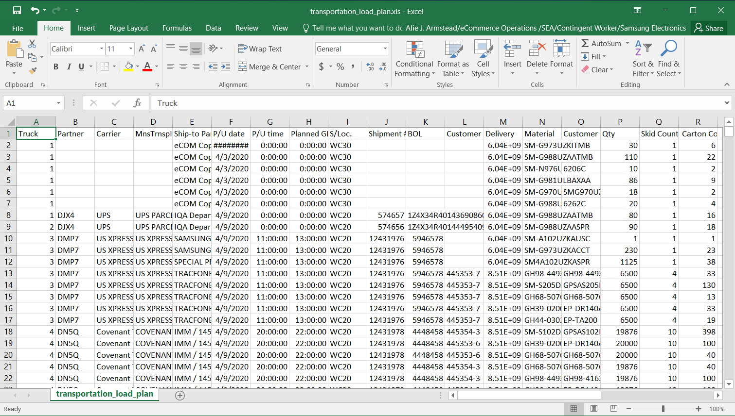
  - Select all, then using filter,
    - Sort the data by, “Ship-to Party(Text)”column;
    - Deselect “Select All”;
    - Select “eCOM Coppell Location / 240 Dividend DR / COPPELL TX 75019”
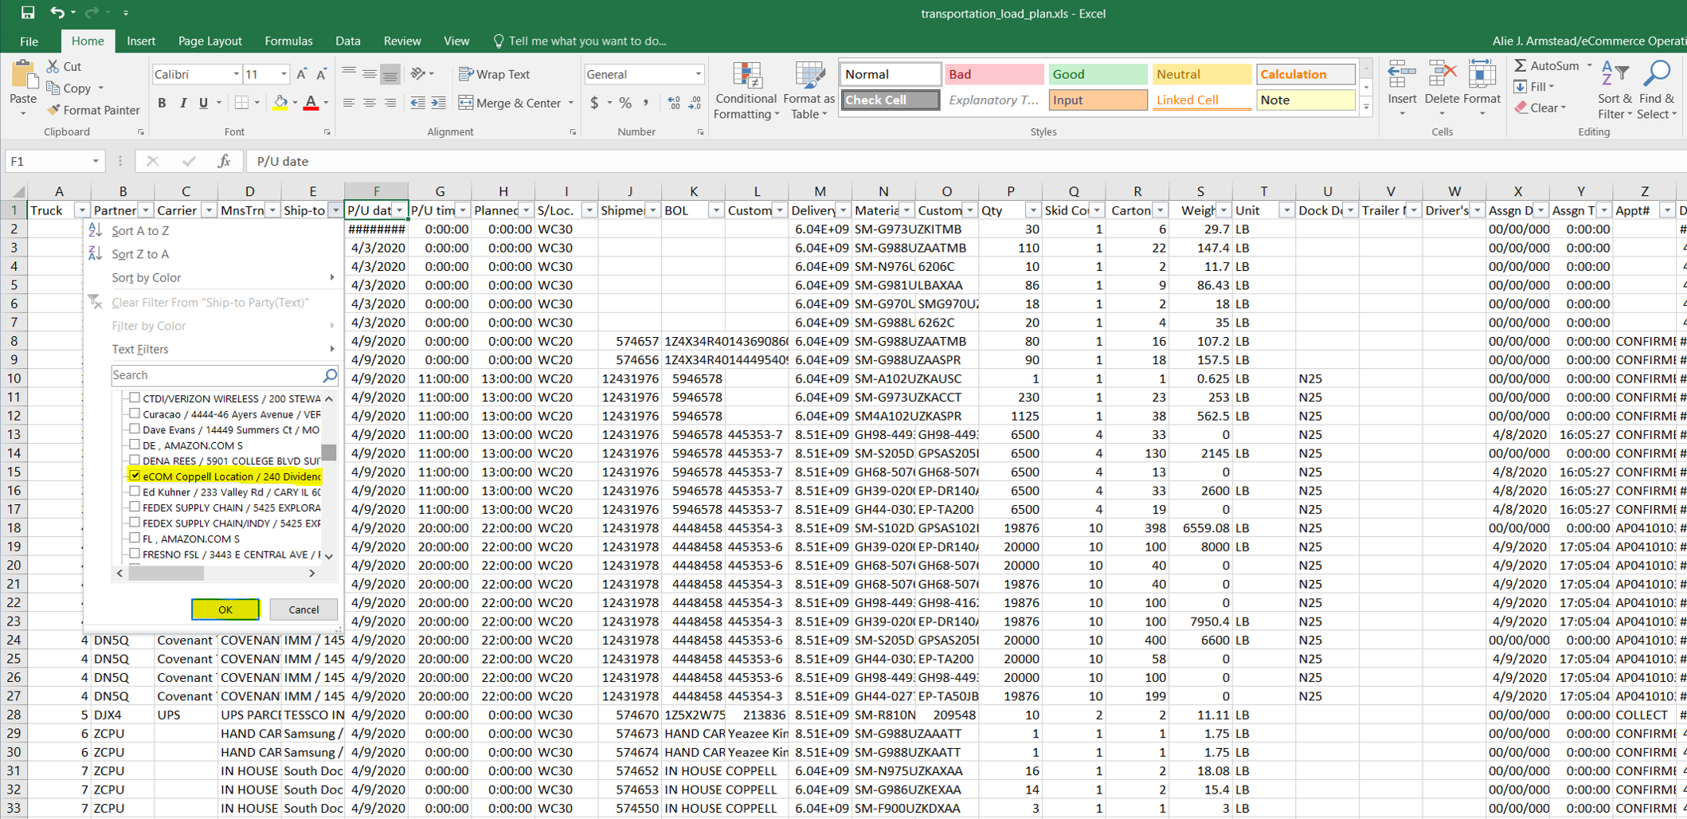

- Create the following new tabs on the spreadsheet: ”eComm Data”, “GI to Geodis”, “North Dock Pending STOs” and “Inbound Floor”
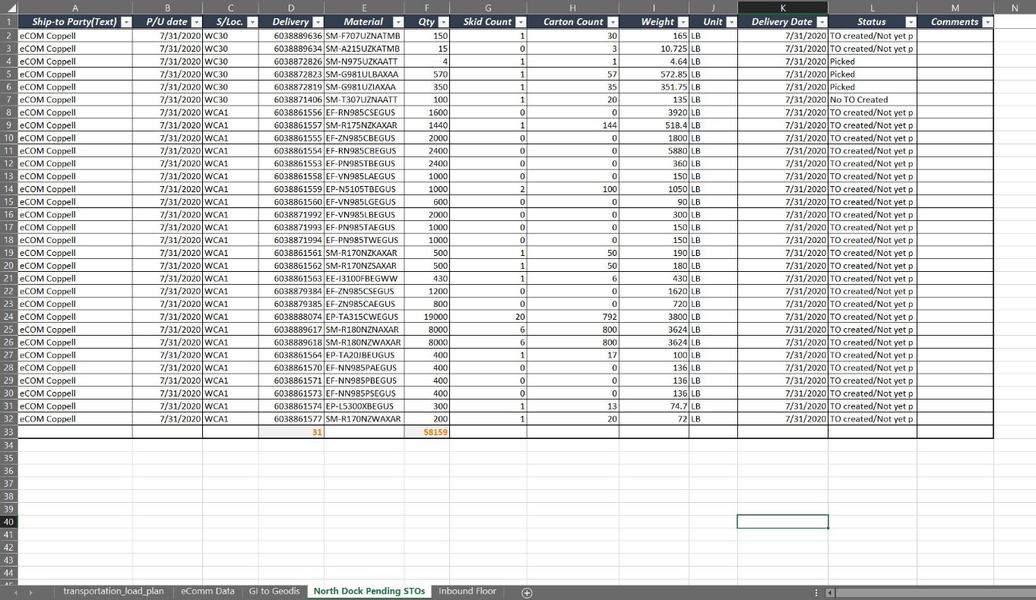
- The data in these sheets can be populated by:
- eComm Data: This sheet has the data that was filtered out in step ‘i’ above.
- GI to Geodis: This sheet can be populated by going to eComm data sheet and,
  - Filter the status column and deselect all.
  - Select ‘KPI violation”and/or “Shipped”.
  - Paste the data in the GI to Geodis sheet.
- North Dock Pending STOs: This sheet can be populated by going to eComm data sheet and,
  - Filter the status column and deselect all.
  - Select ‘TO Created/ not yet p” and/or “No TO created” and or “Picked”.
  - Paste the data in the North Dock Pending STOs sheet.
- Inbound Floor: The STOs on the inbound floor can be found in Geodis Visibility portal
  - Log-in to your Geodis Visibility account
  - Follow the steps shown below to open the search window
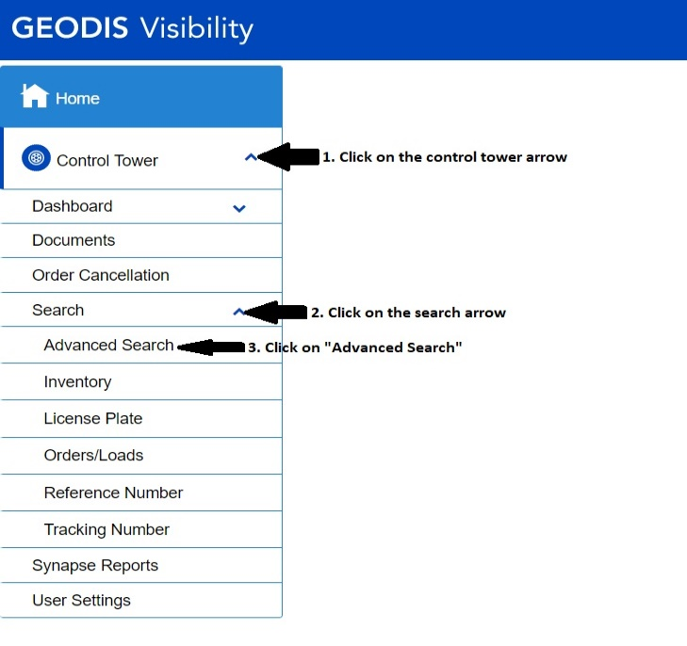
  - Follow the steps to filter out the data accordingly
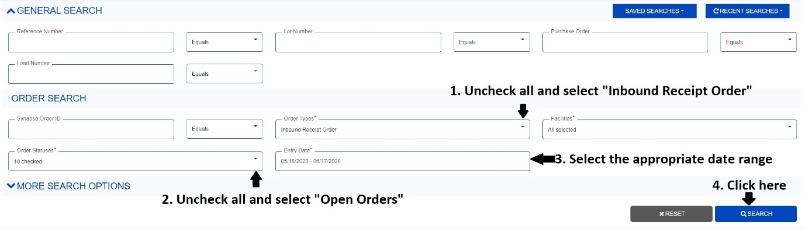

  - Click on the excel icon shown below to export the data
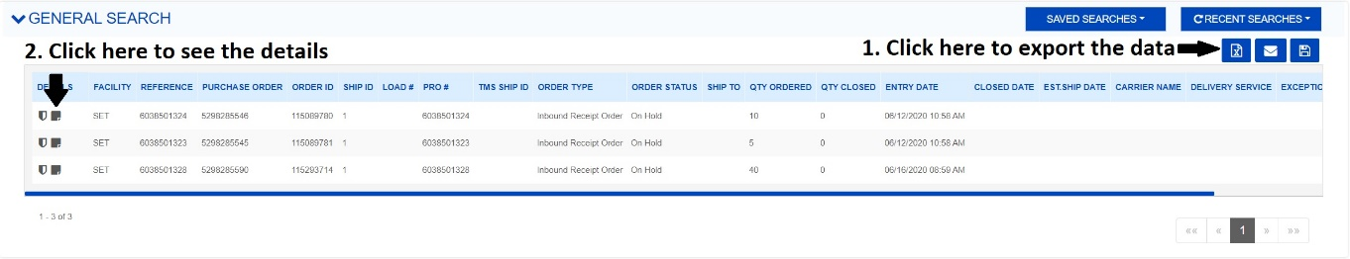
  - The SKU and the description can be found by opening the details. See step 2 in the pic above to open the details and follow the steps shown below
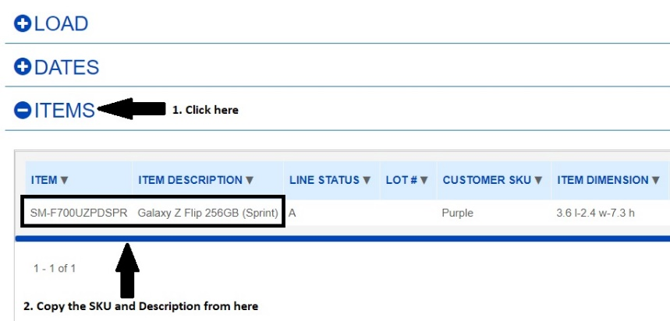
  - Delete the columns where the information does not help us analyze or track the data. Add columns SKU, Description, Cone Status, Age, Comments
  - The final file looks like this. The cells have been colored to depict the appropriate cone color
